**The wicker chair**

**课后单词词组处理方式：录播+课堂上重复重点**

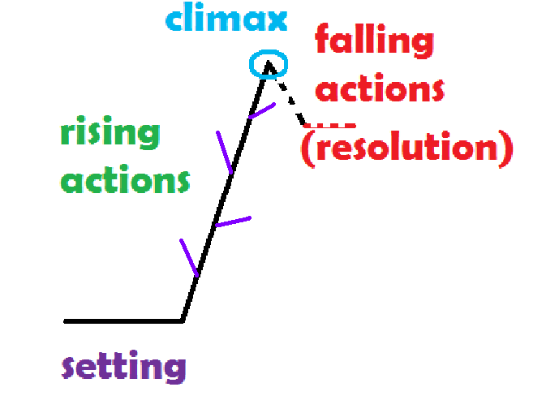

suspense:

**The wicker chair**

key words and expressions

|  |  |
| --- | --- |
| visualize | 想象 |
| assignment | 作业，任务 |
| proceed vs. precede | 继续进行 |
| shrug | 耸肩 |
| dimension | 尺寸，方面 |
| contemplate | 深思，细想 |
| grain | 谷粒，谷物 |
| revenue(s) | 收益，收入 |
| feasible | 可行的 |
| glare (stare, glance等表示看的词) | 怒目而视 |
| groan | 抱怨 |
| interrupt | 打断 |
| index | 索引 |
| oddly | 奇怪地 |
| oddly enough | 奇怪的是，真奇怪 |
| vice versa | 反之亦然 |
| cut one’s losses (with) | 及时脱手以减少损失 |
| pack up (sth) | 离开以前收好物品 |
| smile broadly | 咧着嘴笑 |
| cut into profits | 消减利润 |
| better still | 更好的选择是 |
| hand out | 分发 |
| reason out (= figure out) | 通过推理解释，解决 |
| Think through | 认真考虑（某事可能产生的结果） |
| visualize | 想象 |
| assignment | 作业，任务 |
| proceed vs. precede | 继续进行 |
| shrug | 耸肩 |
| dimension | 尺寸，方面 |
| contemplate | 深思，细想 |
| grain | 谷粒，谷物 |
| revenue(s) | 收益，收入 |
| feasible | 可行的 |
| glare (stare, glance等表示看的词) | 怒目而视 |
| groan | 抱怨 |
| interrupt | 打断 |
| index | 索引 |
| oddly | 奇怪地 |
| oddly enough | 奇怪的是，真奇怪 |
| vice versa | 反之亦然 |
| cut one’s losses (with) | 及时脱手以减少损失 |
| pack up (sth) | 离开以前收好物品 |
| smile broadly | 咧着嘴笑 |
| cut into profits | 消减利润 |
| better still | 更好的选择是 |
| hand out | 分发 |
| reason out (= figure out) | 通过推理解释，解决 |
| Think through | 认真考虑（某事可能产生的结果） |

1 During my senior year in college, I ***took a marketing class*** taught by a ***grumpy*** old man. On the first day of class, he ***made some predictions***. First, he said we would always remember his name. ***Visualize a jack-o'-lantern in the seat of a wicker chair*** and you will always remember Jack Wickert. Second, he said most people would do very badly in this class because he ***had no patience with*** students who don't ***do the assignments and follow instructions***. Last, there would be no more than three As out of the 40 students in the class.

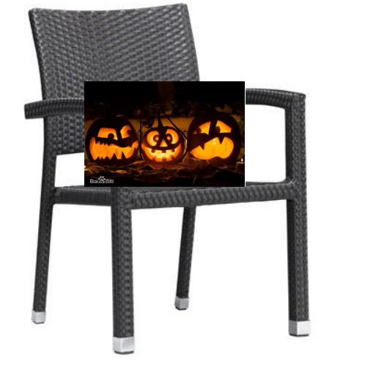

2 He ***made us sweat all semester.*** He taunted and ***jeered at us*** and ***called us stupid.*** However, we did learn something about creative methods for ***marketing products***. ***The final exam was scheduled for*** the ***second-to-last week*** of the semester and we would review the results on the last night of class. On the night of the final exam, Jack Wickert told the class there was only one question. Then he stunned us all by announcing, "This is an open exam. You may look through your books, your notes or anything that will help. You may also do any research you like."

3 Then, Wickert ***proceeded to*** write the problem on the board: Develop a marketing plan for ***an electronic rat trap*** costing $500.

***proceed |prəˈsi:d; 美 proʊ-|***

1. [动词 + 副词或介词短语](formal) to ***move or travel*** in a particular direction 行进；前往

E.g. She climbed the steps and proceeded along the upstairs hallway.

2) go on

Vi ~ (with sth) to ***continue*** doing sth that has already been started; to continue being done 继续做（或从事、进行）

proceed to do: ***go on doing***: to do sth next, after having done sth else first 接着做；继而做

Which meaning?

( )We're not sure whether we still want to *proceed with* the sale. 我们不确定是否还要继续减价促销。

( )He outlined his plans and then *proceeded to* explain them in more detail. 他简单介绍了他的计划，接着又进行了较详细的解释。

( ) Passengers for Rome should proceed to Gate 32 for boarding. 前往罗马的旅客，请到32号登机口登机。

( ) *The building work was proceeding* according to the schedule.

VS precede [prɪˈsi:d] (pre- + cede)

the years preceding the war

She preceded me in the job. 她是我这工作的前任。

See the preceding chapter.

（反义词succeed： Their early success was succeeded by a period of miserable failure.）

proceed or precede

1. She _____ ________ him out of the room.
2. His resignation was __ __________by weeks of speculation.
3. Repeat the exercises described in the ____ ________section.
4. Work is __ _________slowly.
5. (humorous) Having said she wasn't hungry, she then __ _______*to* order a three-course meal.
6. The marchers _______ _____slowly along the street.

造句proceed_________________________________________

造句precede__________________________________________________

4 I ***looked over at*** one of my friends. He ***arched his eyebrow***, shrugged and shook his head. What a horrible thing to have to market. Who's going to spend a whole week's salary on one rat trap? If you really had rats, you were likely to be living in a ***slum*** and certainly couldn't afford such a high price. If you could afford it, you lived where there were no rats.

5 I just sat there, staring at the blackboard. I knew ***there was a catch.*** Knowing Wickert, I'm sure there was ***a trick to this.*** And the answer was easy. He just knew ***we'd be too silly to catch it***. So, I sat there staring and thinking. Finally, I got it! The answer was clear. You couldn't sell it. Write the report, briefly explaining that this was ***not marketable***, ***cut your losses*** and ***move on to*** something practical. So, I wrote it out on one page. I started **packing up my things** and looked up to catch Mr. Wickert looking at me ***with a smug, evil leer***. His look told me that he thought he had won. I sat there looking at him, but he was just sitting there ***smiling broadly***, pretending to read.

6 So, I was forced to reflect on the rat trap. It was so expensive and big (***we had the dimensions***). Where would you even put this thing if you could afford to buy one? ***I contemplated the problem some more***. And more. And more.

7 Slowly, I started to think about large warehouses, factories … places you store things, like food, paper, boxes, grains … ***industrial facilities***. Yes! ***Keep going.*** What else? Stores, supermarkets, restaurants. They could afford this. I was starting to get excited. Yes, they have room to place ***this huge device*** somewhere.

8 But it could ***cut into the revenues of exterminators.*** Yes! Exterminators. What a great market! They could buy them and sell them to their customers. ***Better still,*** they could rent them and collect huge profits. ***And off I went.*** That night, I ***developed*** a 20-page marketing plan. It was logical, reasonable and ***feasible***.

9 I was quite satisfied with my marketing plan and just before 10:00 p.m., I ***dropped it on his des***k. He was still ***looking smug,*** but anyway, I had tried.

10 Next Wednesday, he showed up in class with the results. He announced, "You met my lowest expectations. Most of you ***missed the whole point***, and your grades reflect it. I am annoyed, but I was forced to grant one more A than I had predicted." And he ***glared pointedly at me.*** "There were four this semester."

11 ***He handed out the graded finals and the groans were audible.*** However, I had gotten an A. But why did I sense he wasn't going to let me enjoy it?

12 Wickert interrupted all the complaints. "I warned you at the beginning of the class tha***t if you took the lazy way out, it would cost you.*** If you had followed my instructions, this final would have been ***a slam dunk***. Now that it's over, I can tell you. I ***took the case straight out of the textbook***. ***Verbatim***. I ***did not even bother to*** change the name of the case. I knew you wouldn't notice."

13 ***You could hear the sound of pages rustling as we frantically searched the textbook and the index, looking for the case.*** Then, ***there was dead silence*** as we read it. ***Oddly enough,*** the case's marketing plan turned out to be very similar to my own. They thought up a few things that I hadn't ***and vice versa.***

***turn out***

|  |
| --- |
| 1. to be present at an event 出席（某项活动）；在场 |
| 1. (used with an adverb or adjective, or in questions with how 与副词或形容词连用，或用于以how引导的疑问句) to happen in a particular way; to develop or end in a particular way …地发展（或发生）；结果… |
| 1. to point away from the centre 向外；朝外 （具体，本意） |
| 1. to be discovered to be; to prove to be 原来是；证明是；结果是 |

***Which meaning?***

( )A vast crowd turned out to watch the procession.

( )Despite our worries everything turned out well.

( )You never know how your children will turn out.

( )If the day turns out wet, we may have to change our plans.

( )Her toes turn out.

( )It turned out that she was a friend of my sister.

( )The job turned out to be harder than we thought.

( )The house they had offered us turned out to be a tiny apartment.

***翻译：***

结果一切都顺利。

很难说子女将来的发展怎样。

如果那天下雨的话

她的脚趾向外撇。

她原来是我姐姐的朋友。

这工作结果比我们想象的要难。

***Make a sentence: turn out:***

and vice versa:

1. They want to send students from low-income homes into more affluent neighborhoods and vice versa. 他们想把来自低收入家庭的学生送到较为富裕的地区，反之亦然。

2. It can move from the land or from the oceans to the atmosphere, and vice versa. 它可以从陆地或海洋转移到大气，反之亦然。

Teachers qualified to teach in England are not accepted in Scotland and vice versa. 在英格兰有教书资格的老师在苏格兰得不到认可，反之亦然。

You can cruise from Cairo to Aswan or vice versa (= also from Aswan to Cairo) .

你可以乘船从开罗游览到阿斯旺，也可以从阿斯旺游览到开罗。

"she hates him and vice versa"

*He doesn't [trust](https://dictionary.cambridge.org/zhs/%E8%AF%8D%E5%85%B8/%E8%8B%B1%E8%AF%AD/trust" \o "trust) her, and vice versa (= she also doesn't [trust](https://dictionary.cambridge.org/zhs/%E8%AF%8D%E5%85%B8/%E8%8B%B1%E8%AF%AD/trust" \o "trust) him).*

*She's very [angry](https://dictionary.cambridge.org/zhs/%E8%AF%8D%E5%85%B8/%E8%8B%B1%E8%AF%AD/angry" \o "angry) with him and vice versa.*

“not vice versa” “（但）反之则不然”。

*Dogs often [chase](https://dictionary.cambridge.org/dictionary/english-danish/chase" \o "chase) cats, but not usually vice versa.*

1. According to the second viewpoint, the US now looks to the China for help, but not vice versa. 第二种观点，说美国现在有求于中国，而中国无求于美国。

2. A can call and access b's elements, but not vice versa. A可以调用和访问b的元素，但B不可以访问A的元素。

造句and/or vice versa_________________________________________

造句but not vice versa_________________________________________

14 "Only three people figured out what I had done during the final and ***took the information out of the book.***" He said, "But one person ***did it the hard way*** and actually ***reasoned it out on her own***. It would have saved her a lot of time if she had just done what I had asked."

15 Yes, it would have ***saved me time and embarrassment.*** But, I did figure it out myself, although I hadn't ***followed his directions***. I had t***hought it through*** and ***come up with the correct answer***. Could Wickert have been trying to ***push us young students into thinking***?

16 ***Even to this day*** I wonder if Wickert was ***secretly proud of me***, as well.

proceed 1-1-2-1

proceed or precede (1-3 preceded, preceded, preceding 4-6 *proceeding, proceeded,proceeded* )